[eGifter Choice Card](https://www.egifter.com/giftcards/egifter-choice-card-gift-card)

$5 to $2,000

The eGifter Choice Card gives you total flexibility and choice! Redeem it for a Gift Card from hundreds of retails on eGifter.com or in our mobile apps ranging from Adidas to Whole Foods Market. All Gift Cards bought with eGifter's web or mobile apps can be personalized with a message, animated greeting card, and video greeting. Send Gift Cards for any occasion to your friends and family by email or text. Invite other friends to chip-in and create a Group Gift.

Amazon Gift Card

From $1—

Netflix

From $25-

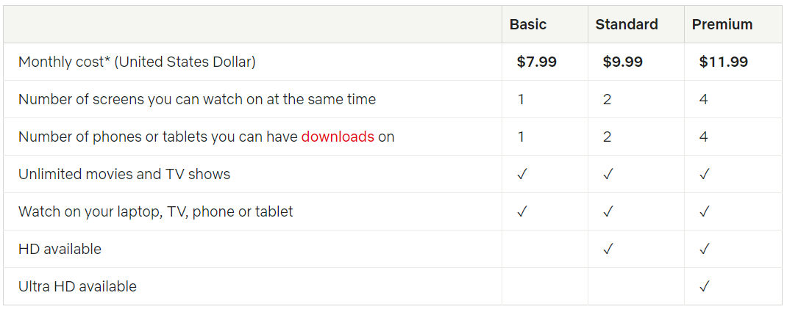

Audible

From $15 - $150

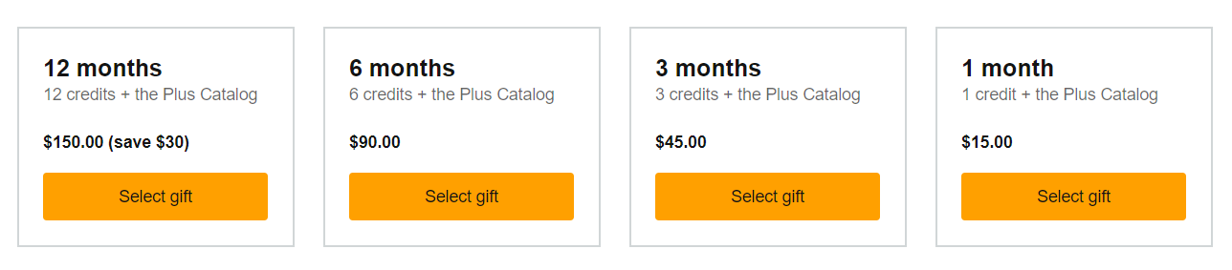

Apple

From $25 –

Spotify

From $10-60 (PayPal)

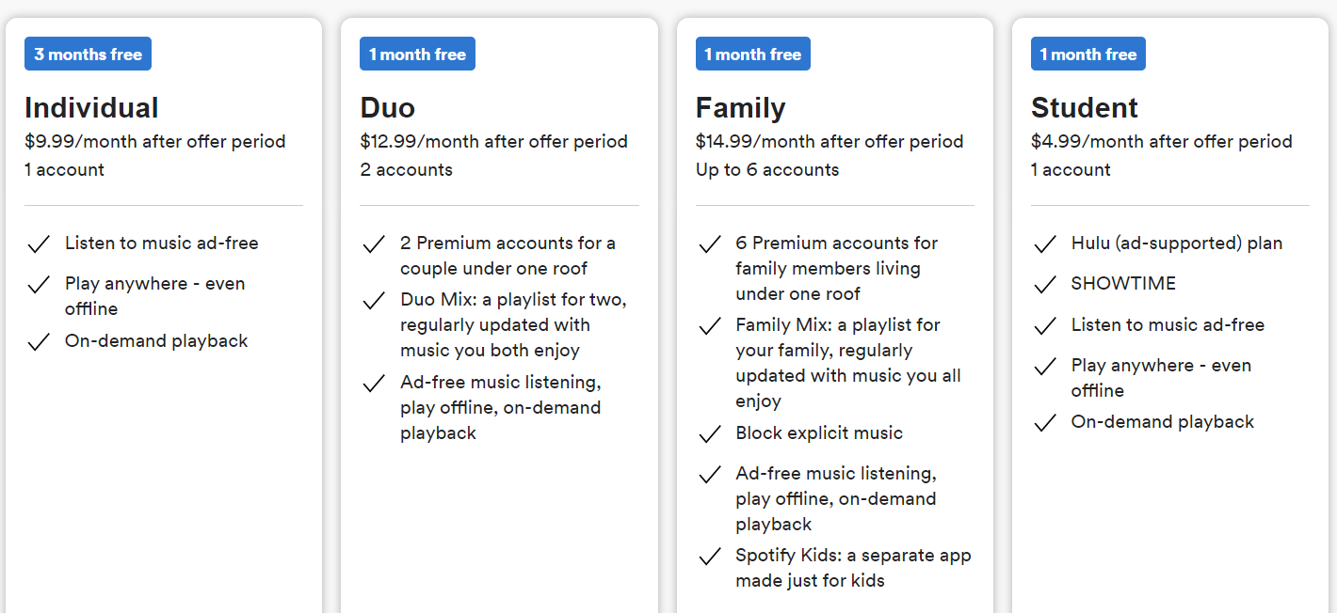

Google Play

From $10- (PayPal)

Probably Country Locked  
[use link](https://getcashforapps.zendesk.com/hc/en-us/articles/204346659-Redeeming-Google-Play-Cards-Internationally)

XBOX

From $10-

Play Station

From $10-

YouTube

From $25

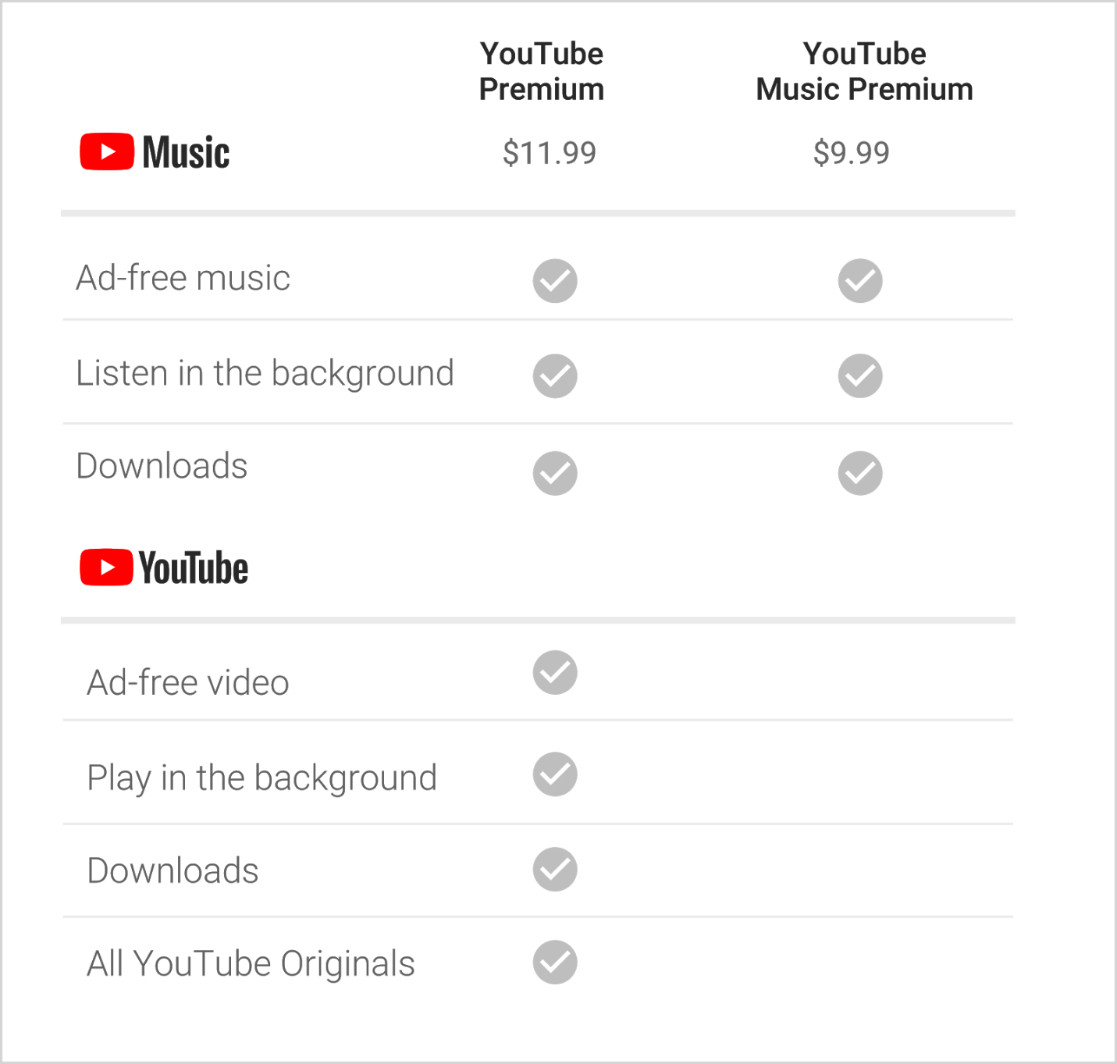

HBO

From $25-

Others